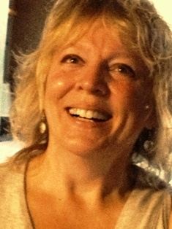Gaioma’s Wisdom
www.gaiomaswisdom.com

We’ve finished the coffee cake and the quiche and pushed our chairs back. Dan is sipping his tea; Lori is contemplating making a cup of same. Eric is asking what everyone is doing for Easter. It’s the monthly gathering of some local clergy and topics range from the local food shelf to sex.
Today, it’s Easter and the accompanying Maundy Thursday, Passover, Good Friday, Ostara holy days that are nearby.
Quickly the conversation takes a quick turn and we are discussing the handshaking at these gatherings and how the covid-19 virus scare affects our groups.
My own grappling is fluid these days. I move from being prepared (I’m a former Girl Scout), to counting the seconds that I soap up the hands, to helping my neighbors who have been quarantined. Yup. You read that right. My hometown is a college town and in one of our formerly empty dorms, we are hosting 31 students who were spending their spring semester studying abroad in Italy. With Italy being one of the global pockets of the virus, the state of New York chose to bring the students home and quarantine them for fourteen days to make sure the virus didn’t show up in any of them.
Back to Easter. I ask myself, “Who am I in the stories surrounding this Christian holiday?” It’s the latest question in my series of how I choose to look at life, asking at each event, “What is the lesson here?”
Am I the supposed to learn on a firsthand level what it feels like to be a refugee? Will my community spawn a hotbed of virus that makes me pack up the dog and the backpack and head to a safer city? Is this the lesson? That I can maybe more deeply understand the terror of my Syrian sister who is fleeing for her life?
Am I supposed to follow Jesus and walk among the lepers to help them know they are no different from others? Should I go to the dorm and write notes on the sidewalk for the quarantined students to see? Should I take them harmonicas and ukuleles from my music room to bide their time?
Am I supposed to live through a bout of the virus to remember compassion for those who have life-threatening illnesses? And then, when it’s over, to ask one more person how I can ease their suffering?
Who am I in the virus story? Grapple with me. Ask the hard questions as citizens of the world. This is not God telling us to be more separate and more alone. It’s God saying, “Be an active participant in creating the world you want to live in.”
The leftover coffee cake is wrapped up and sent home with Jason. The dishes are in the dishwasher. I am contemplating the world I want to live in.

